RPC-Style Interaction

* SOAP XML document will look like a method call

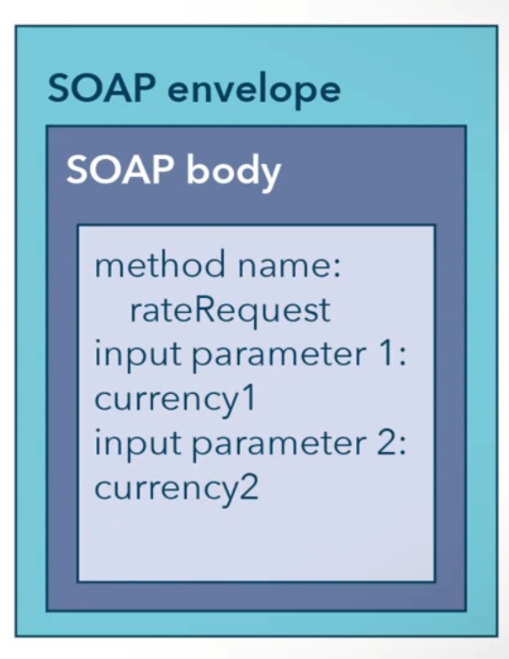

Method Signature for a Currency Exchange Rate (Example)

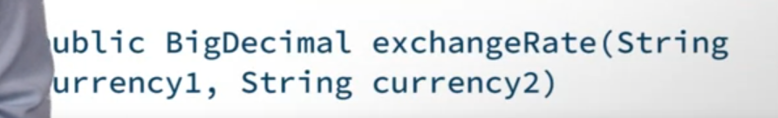

WSDL (Web Service Description Language)

* Somewhat like a method signature
* Created by Microsoft, IBM, Ariba
* Written XML
* Describe interface of a web service
  + How to structure a request
  + Input parameters required
  + Data the service will output

Binding

* Generating the necessary code to interface
* Only after this can the requester invoke the service

WSDL should include more information:

* Types
  + Describe the data types that are used
* Interfaces
  + Formerly port types
  + What operations can be performed and what order
* Bindings
  + Dictate the form of the messages
  + Specifying between document style and RPC Style Interactions
  + Specifying transport protocol
  + Determines how the message is translated in XML
* Services
  + Defined interfaces concretely
  + Assign into endpoints/port located by URIs

Example of WSDL 2.0 (general)

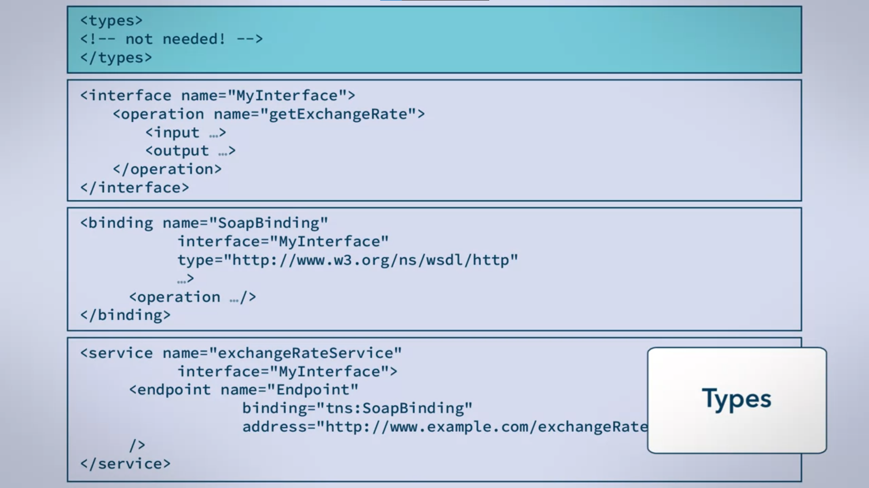

* Basic data types will suffice

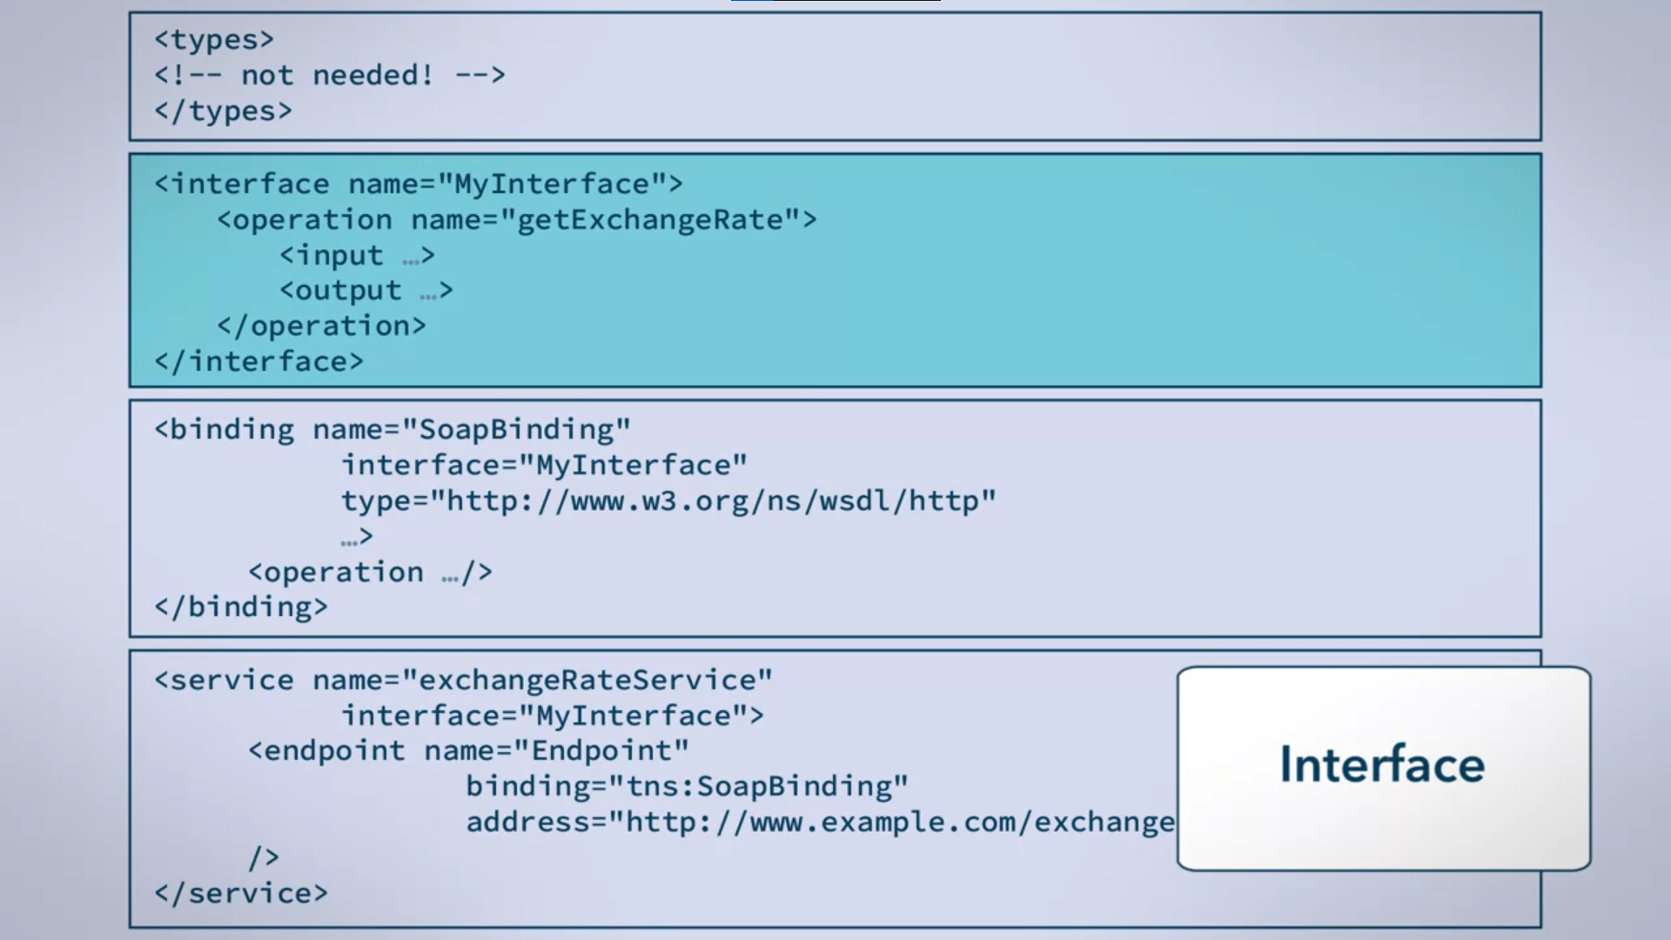

* Request-response style
  + Input – request
  + Output – response

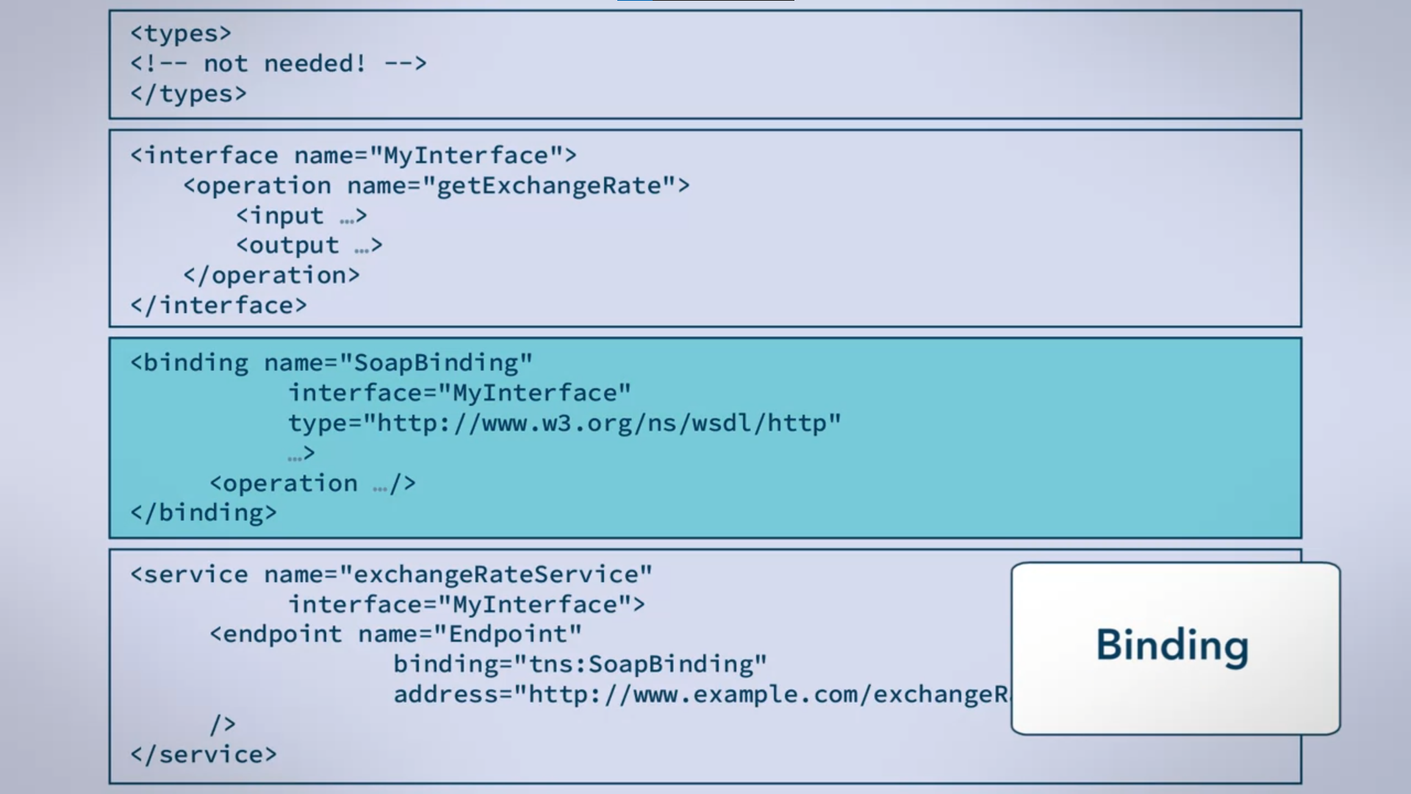

* Uses SOAP
* HTTP protocol

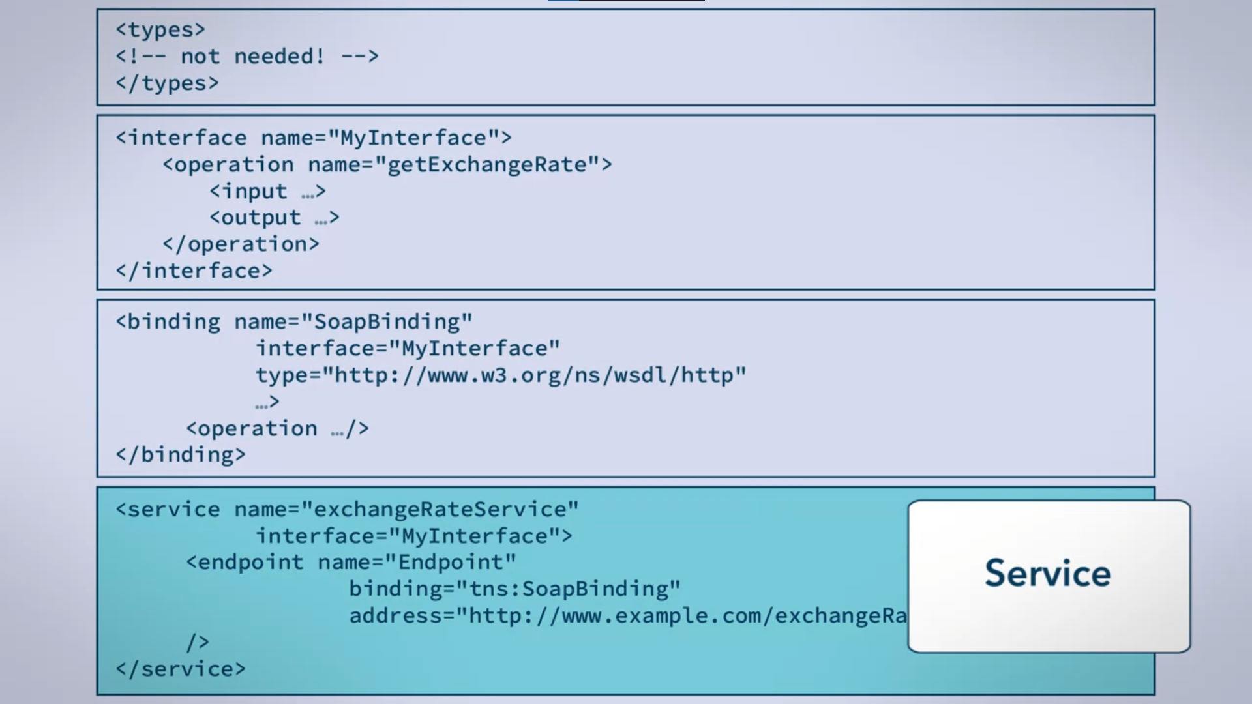

* How services are exposed